Suicide Assessment Tools

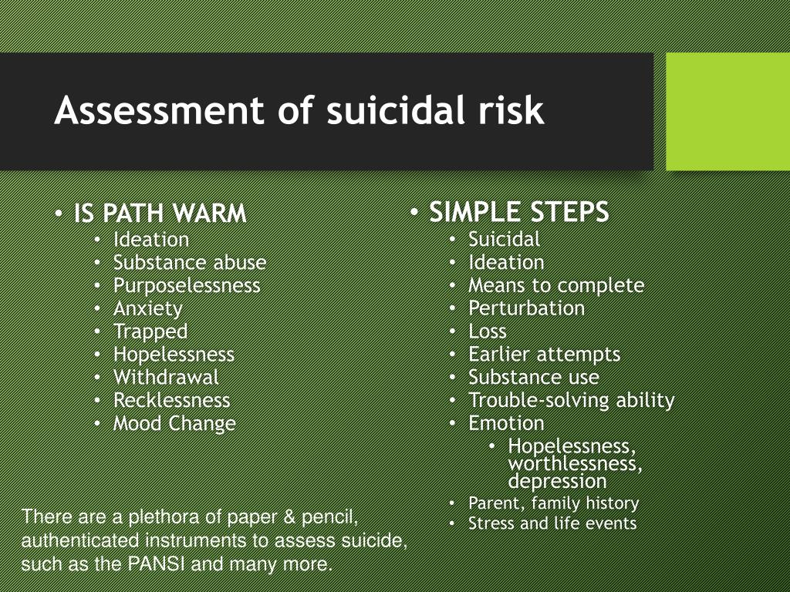

SLAP/DIRT

- Specific plan – has your friend thought about how, where and when he would commit suicide? A plan that is specific is much closer to being carried out than one that is only general: “I don’t know how, but I’m gonna do it.”
- Lethality – how deadly is the plan? I’m not overly concerned about a plan to overdose on Vitamin C, but if someone says they’re going to shoot themselves or jump from a freeway overpass, they have my full attention.
- Availability (of means) – does your friend have or can he easily get what he needs to carry out his plan?
- Proximity (of help) – How close help is can indicate determination. Fred moved in with his daughter and her family after his wife died. They were glad to have him there and Fred did much of the gardening. One evening he said he was going for a walk. He actually went to a park in a neighboring city. In the gazebo in a remote part of the park, Fred put a handgun to his head and pulled the trigger. He went to an isolated place so that there would be no one nearby who could interrupt what he had decided to do.

If there has been a previous attempt(s), add DIRT to the mix:
- Dangerousness – how dangerous were the previous attempts? Is there is a pattern of para- or pseudosuicidal attempts that were deliberately unsuccessful, and is your friend more determined now?
- Impression – whatever the actual danger might have been, what is your friend’s impression of how dangerous her previous attempts were?
- Rescue – how did your friend survive previous attempts? Did they use less than lethal means, or were there friends or other people who came to their rescue?
- Timing – some people attempt suicide expecting to be rescued. Did timing line up for an attempt to be thwarted by somebody else?

Scaling Questions
- On a scale of 1-10, how likely are you to harm yourself/ commit suicide in the next week/day/hour?
- On a scale of 1-10, how intense are your suicidal thoughts right now?

Assess for Duration and Frequency
- When you feel suicidal how long do these feelings last?
- How often do you think about suicide/feel suicidal?

